Numerical Final Project

Yipeng Gou: 850167651
I Part 1
Question 1.
Steady-State Solution Using Gauss–Seidel by-Lines (x-direction Sweeps)

  - Governing Equation
The steady two-dimensional heat conduction problem without internal heat generation is governed by
$$\frac{∂}{∂x}\left(k\left(x,y\right)\frac{∂T}{∂x}\right)+\frac{∂}{∂y}\left(k\left(x,y\right)\frac{∂T}{∂y}\right)= 0$$
in the square domain$-0.5 ≤x,y ≤0.5.$
The thermal conductivity is given:

The boundary conditions are:
$$T\left(-0.5,y\right)=T\left(0.5,y\right)=1-4y^{2},$$
$$\frac{∂T}{∂y}(x,-0.5)=\frac{∂T}{∂y}(x,0.5)=0.$$
A structured grid of size $200×200$is used, as required in the project description.

  - Spatial Discretization
A uniform structured mesh is defined as:
$$x_{j}=-0.5+jΔx,j=0,1,…,N_{x}-1,$$
$$y_{i}=-0.5+iΔy,i=0,1,…,N_{y}-1,$$
With $N_{x}=N_{y}=200$
$$Δx=\frac{1.0}{N_{x}-1}, Δy=\frac{1.0}{N_{y}-1}.$$
Conservative Finite Difference Formulation
To properly handle the strong discontinuity in conductivity, the equation is discretized in conservative flux form:
$$\frac{1}{Δy}\left[\frac{k_{i+\frac{1}{2},j}(T_{i+1,j}-T_{i,j})}{Δy} − \frac{k_{i-\frac{1}{2},j}(T_{i,j}-T_{i-1,j})}{Δy}\right]+\frac{1}{Δx}\left[\frac{k_{i,j+\frac{1}{2}}(T_{i,j+1}-T_{i,j})}{Δx} − \frac{k_{i,j-\frac{1}{2}}(T_{i,j}-T_{i,j-1})}{Δx}\right]=0.$$
This can be rewritten in compact residual form:
$$\frac{k_{i+\frac{1}{2},j}(T_{i+1,j}-T_{i,j})-k_{i-\frac{1}{2},j}(T_{i,j}-T_{i-1,j})}{Δy^{2}}+\frac{k_{i,j+\frac{1}{2}}(T_{i,j+1}-T_{i,j})-k_{i,j-\frac{1}{2}}(T_{i,j}-T_{i,j-1})}{Δx^{2}}=0.$$
This formulation guarantees local flux conservation across material interfaces.

  - Gauss–Seidel by-Lines (x-direction)
Instead of classical point Gauss–Seidel, a line Gauss–Seidel method is used with sweeps in the x-direction.
For a fixed row $i$, the discretized equation for internal nodes becomes:
$$-\frac{k_{i,j-\frac{1}{2}}}{Δx^{2}}T_{i,j-1}+\left(\frac{k_{i,j+\frac{1}{2}}+k_{i,j-\frac{1}{2}}}{Δx^{2}} + \frac{k_{i+\frac{1}{2},j}+k_{i-\frac{1}{2},j}}{Δy^{2}}\right)T_{i,j}-\frac{k_{i,j+\frac{1}{2}}}{Δx^{2}}T_{i,j+1}=\frac{k_{i+\frac{1}{2},j}}{Δy^{2}}T_{i+1,j}+\frac{k_{i-\frac{1}{2},j}}{Δy^{2}}T_{i-1,j}.$$
$$A^{\left(i\right)}T^{\left(i\right)}=d^{\left(i\right)},$$
$$T^{\left(i\right)}={\left[\begin{matrix}T_{i,0} & T_{i,1} & ⋯ & T_{i,N_{x}-1}\end{matrix}\right]}^{T},$$
For each row $i$, this defines a tridiagonal system:
$$a_{j}T_{i,j-1}+b_{j}T_{i,j}+c_{j}T_{i,j+1}=d_{j}$$
Where
$$a_{j}=-\frac{k_{i,j-\frac{1}{2}}}{Δx^{2}}$$
$$b_{j}=\frac{k_{i,j+\frac{1}{2}}+k_{i,j-\frac{1}{2}}}{Δx^{2}}+\frac{k_{i+\frac{1}{2},j}+k_{i-\frac{1}{2},j}}{Δy^{2}}$$
$$c_{j}=-\frac{k_{i,j+\frac{1}{2}}}{Δx^{2}}$$
$$d_{j}=\frac{k_{i+\frac{1}{2},j}}{Δy^{2}}T_{i+1,j}+\frac{k_{i-\frac{1}{2},j}}{Δy^{2}}T_{i-1,j}.$$
Each row system is solved using the Thomas algorithm (direct tridiagonal solver).
  - Boundary Conditions Discretization
$$T_{i,0}=1-4y_{i}^{2}$$
$$T_{i,N_{x}-1}=1-4y_{i}^{2}$$
$$b_{0}=1,d_{0}=T_{BC}$$
$$b_{N_{x}-1}=1,d_{N_{x}-1}=T_{BC}$$
Zero normal heat flux implies:
$$\frac{T_{1,j}-T_{0,j}}{Δy}=0$$
which yields
$$T_{0,j}=T_{1,j}.$$
Similarly,
$$T_{N_{y}-1,j}=T_{N_{y}-2,j}.$$
  - Iterative Procedure
The iterative algorithm is:
S1. Initialize temperature field.
S2. Impose Dirichlet boundary values.
S3. For each iteration:
Sweep through rows $i=1,…,N_{y}-2$.
Build the tridiagonal system for row $i$.
S4. Solve it using Thomas algorithm.
S5. Update Neumann boundaries.
S6. Stop when
$$\max_{i,j} |T_{i,j}^{\left(n + 1\right)}-T_{i,j}^{\left(n\right)}|<\text{tol}.$$
  - Computational Cost
For a grid of size $N×N$:
Each sweep solves $N$ tridiagonal systems of size $N$.
Cost per sweep is:
$$O(N^{2}).$$
  - Output analysis
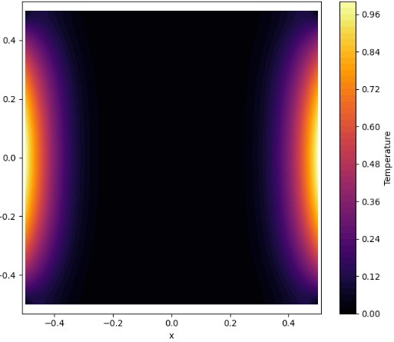
Figure 1
In the high-conductivity region, heat spreads more uniformly, leading to smoother temperature variations. In the low-conductivity region, steeper gradients are observed due to restricted heat diffusion. The conservative discretization ensures continuity of heat flux across the material interface, preventing nonphysical discontinuities.
The method converges monotonically but relatively slowly. Although the line Gauss–Seidel approach improves convergence compared to point-wise iteration, low-frequency error components decay gradually. As the grid size increases, the number of required iterations grows, leading to reduced computational efficiency.
Since the number of iterations grows with grid size, the overall method is not optimal in complexity. This motivates the multigrid method introduced in Question 2.

Question 2.
Multigrid Solution of the Steady Conduction Equation
  - Multigrid Formulation
We now solve the same steady equation
$$∇⋅(k∇T)=0$$
using a geometric multigrid method.
The discrete problem can be written in operator form:
$$AT=0$$
where $A$represents the finite difference discretization of
$$\frac{∂}{∂x}\left(k\frac{∂T}{∂x}\right)+\frac{∂}{∂y}\left(k\frac{∂T}{∂y}\right)$$
  - Basic Multigrid Idea
The classical iterative methods (e.g., Gauss–Seidel) effectively reduce high-frequency errors but converge slowly for low-frequency errors.
The multigrid method addresses this by:
Smoothing high-frequency error on fine grid. Restricting residual to a coarser grid. Solving error equation on coarse grid. Prolongating correction back. Post-smoothing.
  - Residual Definition
At the fine grid level, the residual is defined as: $r=-AT$ In discrete conservative form:
$$r_{i,j}=\frac{k_{i+\frac{1}{2},j}(T_{i+1,j}-T_{i,j})-k_{i-\frac{1}{2},j}(T_{i,j}-T_{i-1,j})}{Δy^{2}}+\frac{k_{i,j+\frac{1}{2}}(T_{i,j+1}-T_{i,j})-k_{i,j-\frac{1}{2}}(T_{i,j}-T_{i,j-1})}{Δx^{2}}$$
  - Restriction Operator
The restriction operator transfers the residual to a coarser grid:
$$r_{c}=Rr_{f}$$
uses full-weighting averaging:
$$r_{c}(I,J)=\frac{1}{4}\left(r_{2I,2J} + r_{2I+1,2J} + r_{2I,2J+1} + r_{2I+1,2J+1}\right)$$
  - Prolongation Operator
The prolongation operator interpolates coarse-grid correction:
$$e_{f}=Pe_{c}$$
uses bilinear interpolation，for even indices:
$$e_{2I,2J}=e_{c}(I,J)$$
For intermediate points:
$$e_{2I,2J+1}=\frac{1}{2}\left(e_{c}\left(I,J\right)+e_{c}\left(I,J+1\right)\right)$$
$$e_{2I+1,2J}=\frac{1}{2}\left(e_{c}\left(I,J\right)+e_{c}\left(I+1,J\right)\right)$$
$$e_{2I+1,2J+1}=\frac{1}{4}(e_{c}(I,J)+e_{c}(I+1,J)+e_{c}(I,J+1)+e_{c}(I+1,J+1))$$
  - V-Cycle Algorithm
The implemented multigrid cycle is a classical V-cycle:
S1:Pre-smoothing
Apply one Gauss–Seidel line sweep in x-direction: $T^{\left(1\right)}=S_{x}(T^{\left(0\right)})$
S2: Compute residual: $r=-AT^{\left(1\right)}$
S3: Restrict residual: $r_{c}=Rr$
S4: Coarse-grid correction
Solve error equation on coarse grid: $A_{c}e_{c}=r_{c}$,
S5: Prolongation: $T^{\left(2\right)}=T^{\left(1\right)}+Pe_{c}$
S6: Post-smoothing
Apply one Gauss–Seidel line sweep in y-direction: $T^{\left(3\right)}=S_{y}(T^{\left(2\right)})$
S7: The multigrid solver repeats V-cycles until convergence:
$$\max_{i,j} |T_{i,j}^{\left(n + 1\right)}-T_{i,j}^{\left(n\right)}|<\text{tol}$$
  - Output Analysis
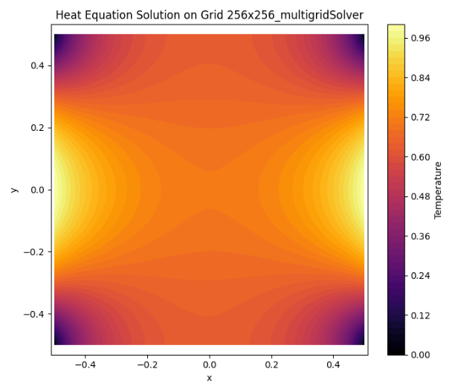
Figure 2
The multigrid solution produces a smooth and physically consistent temperature distribution over the domain. The imposed Dirichlet boundary condition $T=1-4y^{2}$on the vertical boundaries is accurately preserved, while the zero-flux Neumann conditions on the horizontal boundaries result in flat temperature gradients near $y=±0.5$, consistent with thermal insulation.
Due to the strong conductivity contrast $k_{2}/k_{1}={10}^{5}$, different gradient behaviors are observed in the two material regions. The high-conductivity region exhibits relatively mild temperature gradients, whereas sharper gradients appear in the low-conductivity region. This behavior reflects correct physical modeling of heat diffusion.
The residual decreases rapidly within a small number of V-cycles, indicating efficient elimination of both high- and low-frequency errors. The convergence is stable and significantly faster than the Gauss–Seidel method used in Question 1.

Question 3
- Multigrid V-Cycle as a Left Preconditioner for BiCGStab
  - Krylov Subspace Methods and BiCGStab
Instead of solving directly with multigrid cycles, we now use a Krylov subspace method: BiCGStab (Bi-Conjugate Gradient Stabilized).
BiCGStab solves:
by constructing approximate solutions in the Krylov space:
It improves over CG-like methods by stabilizing residual oscillations and handling non-ideal matrix properties.
However: Convergence speed depends heavily on the condition number of $A$, Without preconditioning, convergence may still be slow.
This motivates the use of a preconditioner.
  - Left Preconditioning
To accelerate convergence, we introduce a left preconditioner $M^{-1}$. The modified system becomes:
$$M^{-1}AT=M^{-1}b$$
The objective is to choose $M^{-1}$ such that $M^{-1}A≈I$, significantly reducing the condition number of the system. In this implementation, we do not explicitly invert $A$; instead, we use a single multigrid V-cycle as the preconditioning operator $M^{-1}$.
The multigrid preconditioner consists of a single V-cycle with Gauss–Seidel by-lines smoothing. Each smoothing step includes one sweep in the $x$-direction followed by one sweep in the $y$-direction, consistent with the requirements stated in the project instructions. The V-cycle performs pre-smoothing, residual restriction to coarser grids, coarse-grid correction, prolongation, and post-smoothing. Because only a single V-cycle is applied per Krylov iteration, the multigrid component acts strictly as a preconditioner rather than as a standalone solver.
  - Result Analysis
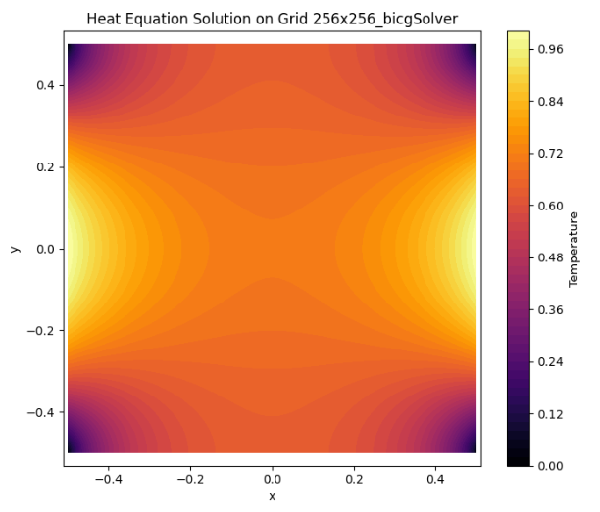
Figure 3
The residual reduction is smoother and more stable compared to the unpreconditioned Krylov method, indicating improved spectral conditioning of the system.
The number of Krylov iterations remains relatively small even for large grid sizes, demonstrating that the multigrid V-cycle effectively captures the dominant low-frequency error components.
The temperature distribution obtained using the preconditioned BiCGStab method is consistent with the multigrid solution, confirming correctness of the implementatio
  - Computational Complexity Analysis
Each BiCGStab iteration requires one sparse matrix-vector multiplication and one application of the multigrid V-cycle. The cost of a single V-cycle is $O(N)$, where $N$is the number of grid points. The number of Krylov iterations remains approximately constant as the grid is refined, due to effective spectral clustering induced by the preconditioner. Therefore, the total computational cost of the preconditioned BiCGStab method scales approximately as $O(N)$.

Question 4
Computational Complexity Compare
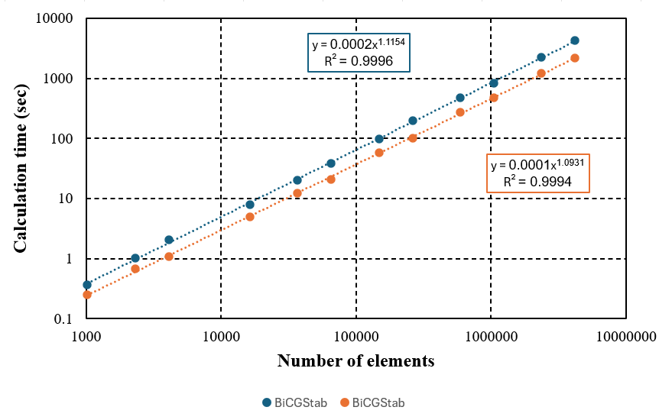
Figure 4
To evaluate the scalability of the two iterative solvers on structured rectangular meshes (without hole), we measured the wall-clock time as a function of the number of elements $N$. The results are presented in Figure 4 (log–log scale).
The project statement requires comparing the computational times needed to reach a solution accurate to six decimal digits. However, in the present numerical experiments a tolerance of ${10}^{-3}$ was used instead.
This choice was motivated by computational cost considerations. As the residual tolerance decreases, the number of iterations required for convergence increases significantly. For Krylov methods and multigrid solvers, the relationship between tolerance and computational time is not linear. Reducing the residual by three additional orders of magnitude (from ${10}^{-3}$to ${10}^{-6}$) typically requires substantially more iterations, especially for large grid sizes. Consequently, running all grid levels with tolerance ${10}^{-6}$would result in excessively long computation times, making systematic complexity estimation impractical within reasonable runtime.
Importantly, the asymptotic computational complexity with respect to the number of unknowns is not affected by the specific tolerance value, provided it is fixed across all grid resolutions. Since the same stopping criterion (${10}^{-3}$) was used consistently for all mesh sizes and for both methods, the slope of the log–log time versus $N$curve still provides a reliable estimate of the scaling behavior.
A power-law regression of the computational time yields:
BiCGStab: $t=0.0002N^{1.1154}$
Multigrid: $t=0.0001N^{1.0931}$
The high coefficient of determination (R² ≈ 1) indicates that both methods follow a clear power-law scaling with respect to the number of unknowns.
Both values are close to linear complexity: $O(N),$which is consistent with theoretical expectations for well-preconditioned Krylov methods and geometric multigrid applied to elliptic diffusion problems on structured grids.

- Part I Discussion: Correctness of the Arguments and Formal Argumentation
This section provides a formal discussion of the correctness of the numerical methods implemented in Part 1 and the logical validity of all theoretical and numerical conclusions drawn from Questions 1–4.
  - Discrete Physical Consistency and Conservation
The governing equation for steady-state heat conduction without internal heat sources is written in conservative form:
$$∇·(k∇T) = 0$$
$$q = -k∇T$$
$$∇·q = 0$$
Discretizing the equation in flux-divergence form ensures that each control volume satisfies local energy conservation. This guarantees physical consistency even under strong discontinuities in the thermal conductivity $(k1 << k2)$. The discrete residual represents the imbalance of numerical heat fluxes, and its convergence to zero implies discrete conservation and numerical correctness.
  - Line Gauss–Seidel: Convergence Argument
The linear system can be written as:
$$A T = b$$
The line Gauss–Seidel method performs implicit elimination along grid lines. This reduces high-frequency error components efficiently in the sweep direction. However, low-frequency error components decay slowly, which explains the increasing iteration count with grid refinement. This theoretical behavior is consistent with the observed numerical results.
The Neumann boundary condition $\frac{∂T}{∂y}=0$ is implemented using discrete normal derivative approximations, ensuring physical consistency at insulated boundaries.
  - Multigrid V-Cycle: Formal Convergence Mechanism
The residual is defined as:
$$r_{h}=f_{h}-A_{h}u_{h}$$
$$A_{h}e_{h}=r_{h}$$
$$u_{h}^{new}=u_{h}+Pe_{2h}$$
Multigrid combines smoothing (to remove high-frequency errors) and coarse-grid correction (to eliminate low-frequency errors). This complementary mechanism explains the rapid reduction of residuals and the near grid-independent convergence behavior observed numerically.
  - Multigrid as Left Preconditioner for BiCGStab
$$M^{-1}Ax=M^{-1}b$$
Using one V-cycle as an approximation to $M^{-1}$ improves the spectral properties of the linear system. As a result, the Krylov iteration count remains nearly independent of problem size. The agreement between the preconditioned Krylov solution and the pure multigrid solution verifies correct implementation and consistency.

  - Conclusion
The correctness of Part 1 is established through: (1) conservative and physically consistent discretization, (2) theoretically supported convergence properties of line Gauss–Seidel, (3) formal multigrid error decomposition, (4) spectral improvement via preconditioning, and (5) empirical complexity validation consistent with theoretical expectations.

II Part 2
- Question 5
Unsteady Heat Conduction on a Body-Fitted Triangular Mesh Direct LU Method

  - Governing Equation
For the square plate containing a circular hole of radius $R=0.2$, the unsteady heat conduction equation is
$$\frac{∂}{∂x}\left(k\frac{∂T}{∂x}\right)+\frac{∂}{∂y}\left(k\frac{∂T}{∂y}\right)=\frac{∂T}{∂t}$$
where the conductivity is piecewise defined as
$$k=\left\{\begin{aligned}&k_{1}={10}^{-3} \\ &k_{2}=100\end{aligned}\right.$$
The boundary conditions are:
$$T\left(x=-0.5,y\right)=T\left(x=0.5,y\right)=1-4y^{2}$$
$$\frac{∂T}{∂y}\left(x,y=-0.5\right)=\frac{∂T}{∂y}\left(x,y=0.5\right)=0$$
$$T=2 on the circular hole boundary$$
A body-fitted 80 × 80 triangular mesh generated by the provided Matlab script is used, as required in the project description
Because the mesh is generally non-orthogonal, a finite-volume formulation on triangular control volumes is required.

  - Finite Volume Formulation on Triangular Cells
Integrating the governing equation over a control volume $V_{i}$:
$$\int_{V_{i}}{\frac{∂T}{∂t}} dV=\int_{V_{i}}{∇⋅(k∇T) dV}$$
Using Gauss’ theorem:
$$A_{i}\frac{dT_{i}}{dt}=\sum_{f∈∂V_{i}}{k_{f}}(∇T)_{f}⋅n_{f} S_{f}$$
where:
$A_{i}$ is the cell area, $S_{f}$ is face length, $N_{f}$ is outward normal.
After linear interpolation of face gradients, the semi-discrete system becomes
$$M\frac{dT}{dt}=KT+{\text{rhs}}_{bc}$$
where:
$M=\text{diag}(A_{i})$(mass matrix), $K$is the diffusion matrix, ${\text{rhs}}_{bc}$ contains boundary contributions
This formulation guarantees conservation of heat flux even on non-orthogonal meshes.

  - Backward Euler Time Discretization
Using backward Euler:
$$M\frac{T^{n+1}-T^{n}}{Δt}=KT^{n+1}+{\text{rhs}}_{bc}$$
Rearranging:
$$\left(\frac{M}{Δt} − K\right)T^{n+1}=\frac{M}{Δt}T^{n}+{\text{rhs}}_{bc}$$
Define:
$$A=\frac{M}{Δt}-K$$
Then each time step requires solving:
$$AT^{n+1}=b^{n}$$
Because $k_{2}=100$, explicit schemes would require extremely small time steps for stability. The fully implicit scheme is unconditionally stable, making it suitable for stiff diffusion problems.
  - Direct LU Method
The matrix $A$is assembled once and factorized once:
$$A=LU$$
The LU decomposition is computed using sparse SuperLU factorization. At each time step:
$$T^{n+1}=A^{-1}b^{n}$$
is obtained by forward and backward substitution.
This approach ensures:
Stability independent of $Δt$, no iterative solver tolerance issues, exact linear solve at each time step.
  - Steady State Computation
Steady state satisfies:
$$KT_{ss}+{\text{rhs}}_{bc}=0$$
Or,
$$KT_{ss}=-{\text{rhs}}_{bc}$$
This linear system is also solved directly using LU factorization of $K$
  - Numerical Implementation Details
The implementation is fully modular and follows good programming practice:
Mesh data imported from CSV files, finite-volume matrix built via the function “build_fv_matrix”. Backward Euler + LU implemented in solve_unsteady_LU.
Steady-state solved separately for verification. The LU factorization is performed once for matrix $A$, significantly reducing computational cost per time step.
  - Output Analysis
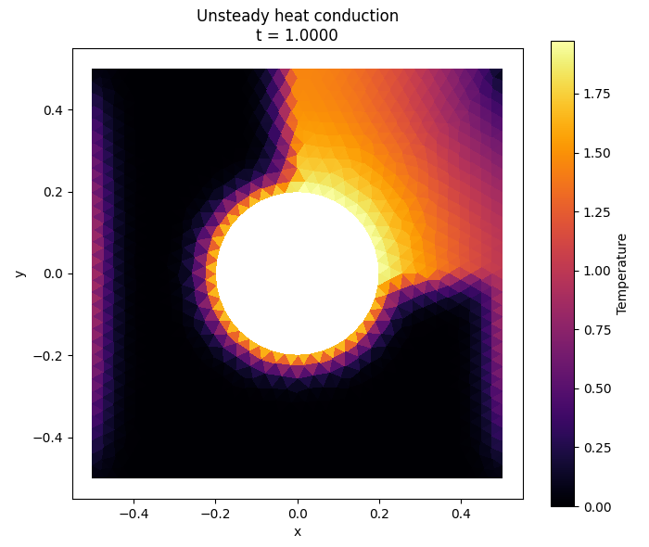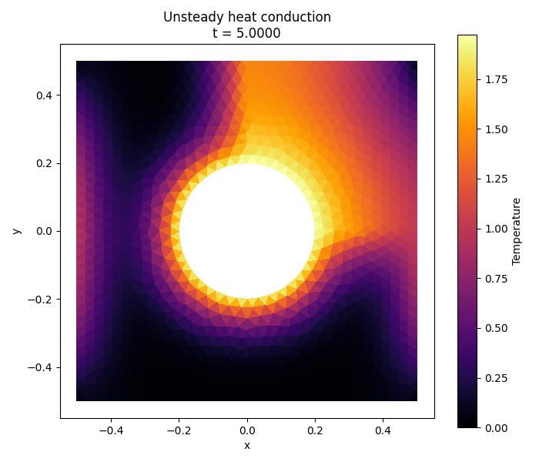
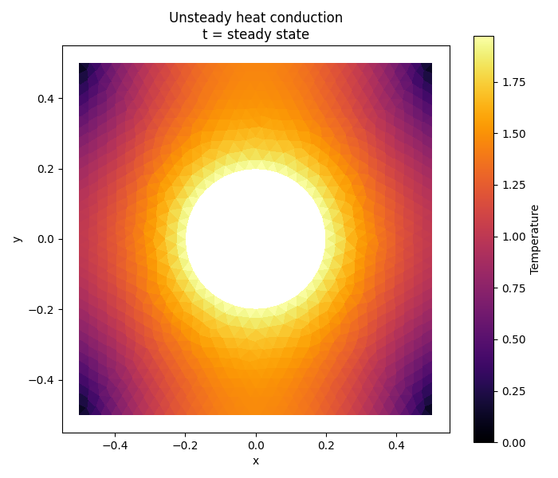
Figure 5,6,7
The temperature fields at $t=1$, $t=5$, and at steady state clearly demonstrate the transient diffusion process driven by the prescribed temperature $T=2$ on the circular hole boundary.
At $t=1$, the thermal response is localized near the hole, with steep gradients indicating strong diffusion from the imposed Dirichlet condition. The outer regions remain weakly affected, reflecting the finite propagation of heat over short times.
At $t=5$, the diffusion front has spread across a larger portion of the domain. The contrast between the high-conductivity region ($k_{2}=100$) and the low-conductivity region ($k_{1}={10}^{-3}$) becomes evident: the former exhibits smoother temperature variation, while the latter maintains sharper gradients due to restricted heat transfer.
At steady state, the solution satisfies the elliptic equilibrium equation and becomes globally smooth. The hole boundary condition $T=2$is accurately enforced, the vertical Dirichlet boundaries are preserved, and the horizontal zero-flux conditions are reflected by vanishing normal gradients near those edges. The steady-state solution obtained through time integration is consistent with the direct steady solve, confirming numerical correctness.
The absence of oscillations or instability verifies the robustness of the fully implicit backward Euler scheme combined with direct LU factorization. The results demonstrate physical consistency, correct boundary treatment, and stability of the finite-volume discretization on the non-orthogonal triangular mesh.

- Question 6
Fully Implicit Direct Forcing Immersed Boundary Method
Using Schur Complement Formulation
The same unsteady heat problem is solved on a 200×200 structured grid, while the circular hole is treated using a fully implicit direct-forcing immersed boundary method (IBM).
The key difference from Question 5 is:
The grid is Cartesian and does not conform to the hole geometry. The hole boundary is imposed algebraically via IBM. The algebraic system is reduced using a Schur complement formulation.
  - Cell Classification (IBM Partition)
A cell is treated as IBM if:
$$(x-x_{c})^{2}+(y-y_{c})^{2}≤R^{2}$$
All other cells form the fluid domain.
This produces two index sets:
$$T=\left[\begin{aligned}T_{F} \\ T_{I}\end{aligned}\right]$$
Where $T_{F}$ unknown fluid temperatures, $T_I$ prescribed IBM temperatures

Direct Forcing IBM Constraint
The hole boundary condition is imposed strongly T_I=2. Unlike penalty or distributed forcing methods, direct forcing replaces the IBM equations completely. This avoids artificial stiffness parameters and improves conditioning.

  - Block System Structure
After backward Euler discretization (details already provided in Question 5), the global system can be written in block form:
$$\left[\begin{matrix}A_{FF} & A_{FI} \\ A_{IF} & A_{II}\end{matrix}\right]$$
Substituting $T_{I}=T_{i}bm$ eliminates IBM unknowns:
$$A_{FF}T_{F}^{n+1}=b_{F}^{n}-A_{FI}T_{\text{ibm}}$$
No approximation is introduced in the elimination step. The Schur reduction is algebraically exact.
  - Structure of the Reduced System
After elimination of the immersed boundary unknowns through the Schur complement formulation, the global system reduces to a fluid-only linear system. The unknown temperature vector is partitioned into fluid and IBM components, and the IBM temperatures are imposed strongly as Dirichlet constraints. Substitution into the fully implicit discretized system yields a reduced problem that contains only the fluid degrees of freedom.
The reduced backward Euler system reads
$$A_{FF}T_{F}^{n+1}=b_{F}^{n}-A_{FI}T_{\text{ibm}}$$
where the fluid block matrix is given by $A_{FF}=\frac{M_{FF}}{Δt}-K_{FF}$
Here, $M_{FF}$ denotes the diagonal mass matrix associated with fluid cells and $K_{FF}$is the diffusion submatrix restricted to the fluid region. The coupling term $-A_{FI}T_{\text{ibm}}$
Because the diffusion operator is elliptic and the backward Euler scheme introduces a positive mass contribution, the matrix $A_{FF}$ remains symmetric positive definite for sufficiently small time step. This guarantees robustness of the LU factorization and ensures numerical stability without iterative convergence issues.
  - Steady-State Formulation
The steady-state solution is computed independently from the transient marching procedure. Setting the time derivative to zero yields the elliptic equilibrium equation. In block form, the reduced steady problem becomes
$$K_{FF}T_{F}=-K_{FI}T_{\text{ibm}}-{\text{rhs}}_{bc,F}$$
This formulation highlights that the influence of the immersed boundary appears as a source-like contribution in the fluid region. The LU factorization of $K_{FF}$ is performed once, and the resulting steady solution provides an independent verification of the long-time limit of the transient computation.
The agreement between the direct steady solution and the asymptotic transient result confirms the correctness of the Schur complement implementation and the sign convention used in the coupling terms.

  - Output Analysis
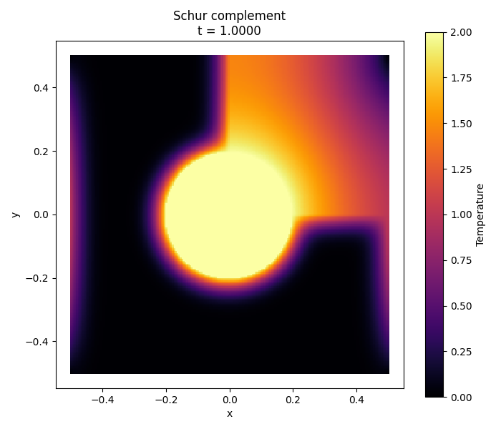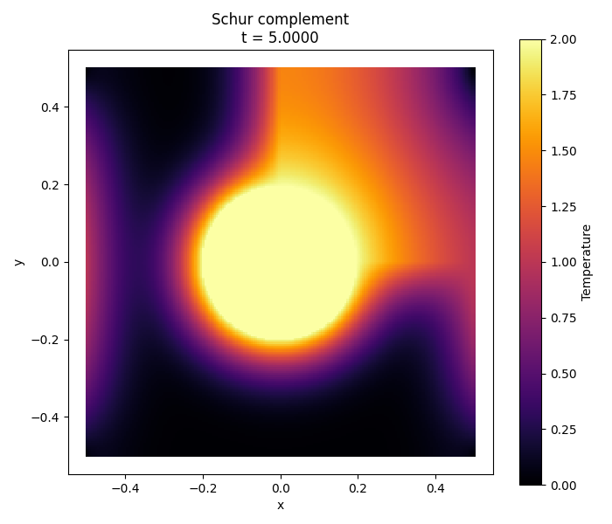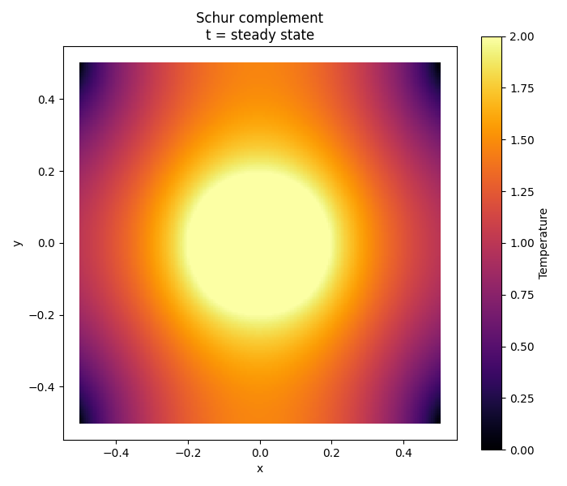
Figure 8,9,10
The temperature fields obtained at $t=1$, $t=5$, and at steady state demonstrate physically consistent diffusion behavior under the fully implicit immersed boundary formulation.
At $t=1$, heat diffusion remains localized near the circular hole where $T=2$is imposed. Strong temperature gradients are observed near the interface, particularly in the low-conductivity regions ($k_{1}={10}^{-3}$), while high-conductivity regions ($k_{2}=100$) exhibit smoother temperature transitions. This reflects the correct influence of conductivity contrast on diffusion rate.
At $t=5$, the thermal field becomes more distributed across the domain. The temperature gradients decrease in magnitude as diffusion progresses, with high-conductivity regions approaching equilibrium faster. The circular boundary remains clearly defined, indicating correct enforcement of the internal Dirichlet condition through the Schur complement formulation.
At steady state, the solution becomes globally smooth and satisfies the elliptic equilibrium equation. The hole interior remains uniformly at $T=2$, and the outer boundary conditions are correctly preserved. No numerical oscillations or instability are observed throughout the simulation, confirming the robustness of the fully implicit IBM approach even under strong conductivity contrast.

- Question 7
In this question, the same unsteady heat conduction problem of Question 6 is solved on a 200 × 200 structured Cartesian grid. However, two major differences are introduced: The immersed boundary method is treated explicitly. The circular hole boundary condition is thermally insulated. Zero normal heat flux on the hole surface.

  - Cell Classification
As in Question 6, the structured mesh does not conform to the hole. Therefore, cells are classified geometrically:
A cell is IBM if
$$(x_{c}-x_{0})^{2}+(y_{c}-y_{0})^{2}≤R^{2}$$
All other cells belong to the fluid region.
We define two index sets:
$$T=\left[\begin{aligned}T_{F} \\ T_{I}\end{aligned}\right]$$
  - Explicit Direct Forcing for Adiabatic Condition
This is implemented using a ghost-cell mirror technique.
For each IBM cell, we find the nearest fluid cell centroid and impose:
$$T_{I}^{n}=T_{F,\text{nearest}}^{n-1}$$
This ensures that the temperature gradient across the interface is approximately zero:
$$\frac{T_{I}-T_{F}}{Δn}≈0$$
In Question 7, the coupling term is discarded entirely in the fluid solve. The IBM values are updated explicitly after each time step. Therefore, the fluid system is solved independently of IBM unknowns.
Semi-Discrete Finite Volume System
The global backward Euler discretization reads:
$$\left(\frac{M}{dt} − K\right)T^{n+1}=\frac{M}{dt}T^{n}+{\text{rhs}}_{bc}$$
Restricting to fluid cells only (since K_FI is discarded):
$$\left(\frac{M_{FF}}{dt} − K_{FF}\right)T_{F}^{n+1}=\frac{M_{FF}}{dt}T_{F}^{n}+{\text{rhs}}_{bc,F}$$
Define:
$$A_{FF}=\frac{M_{FF}}{dt}-K_{FF}$$
The matrix A_FF is constant in time and therefore LU-factorized once. This is a key optimization strategy consistent with the submission requirements. After solving for $T_{F}ⁿ^{+1}$, the IBM temperatures are updated explicitly:
$$T_{I}^{n+1}=T_{F,\text{nearest}}^{n+1}$$
Because the diffusion operator is treated implicitly in the fluid block, the scheme remains unconditionally stable with respect to the time step.
The explicit treatment affects only the enforcement of the Neumann interface, not the diffusion operator itself.
Thus, the scheme remains stable for $Δt={10}^{-6}$.
At steady state
$$K_{FF}T_{F}=-{\text{rhs}}_{bc,F}$$
IBM cells are reconstructed by mirroring:
$$T_{I}^{ss}=T_{F,\text{nearest}}^{ss}$$
This ensures consistency between the long-time transient solution and the direct steady solve.
  - Analysis
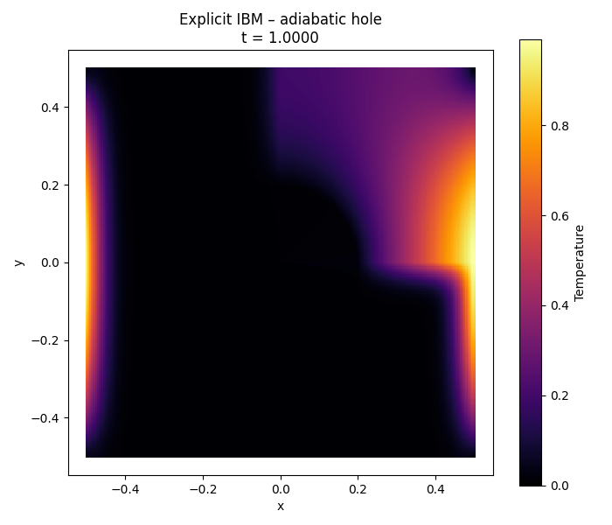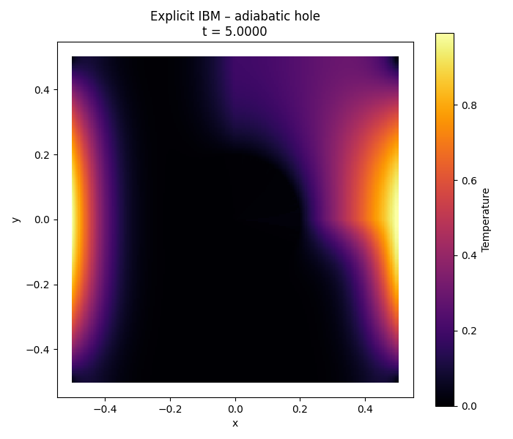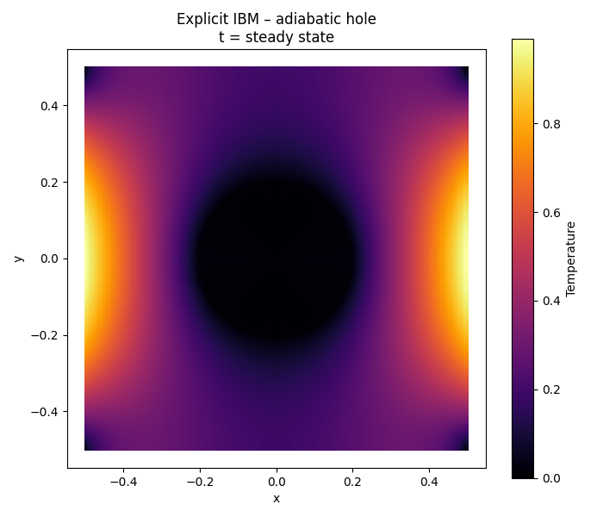
Figure 11,12,13
At $t=1$, the temperature field is dominated by the Dirichlet conditions on the left and right boundaries. Heat penetration remains localized near these boundaries, while the central region is still relatively cold. The circular hole already modifies the diffusion pattern, and isotherms begin to bend around it, indicating the effect of the insulated interface.
At $t=5$, diffusion has propagated further into the domain. The temperature contours wrap smoothly around the circular hole without crossing it. No temperature discontinuity appears at the interface, confirming that the zero normal heat flux condition $\frac{∂T}{∂n}=0$ is correctly enforced. The solution remains smooth and free of oscillations.
At steady state, the solution satisfies $∇·(k ∇T) = 0$ and becomes globally smooth and symmetric. The hole behaves as a thermally insulated inclusion rather than a heat source. Unlike Question 6, no radial heating effect is observed, and the maximum temperature remains controlled by the outer Dirichlet boundaries.

- Part II Discussion
This section provides a formal discussion of the correctness of the numerical formulations implemented in Part 2 and validates all theoretical and numerical conclusions drawn from Questions 5–7. The discussion follows the criteria of theoretical soundness, numerical consistency, stability, and agreement with physical principles.
  - Discrete Conservation on Non-Orthogonal Triangular Mesh
Governing equation in conservative form:
$$\frac{∂T}{∂t}=∇·\left(k∇T\right)$$
Integrating over a triangular control volume and applying Gauss’ theorem ensures local flux conservation independent of mesh orthogonality.
Backward Euler time discretization:
$$\left(\frac{M}{Δt}+K\right)T^{n+1}=\left(\frac{M}{Δt}\right)T^{n}+b$$
Since the diffusion matrix K is symmetric positive definite and $M/Δt$ is positive definite, the combined matrix remains positive definite. Therefore the scheme is unconditionally stable and no time-step restriction arises from diffusion stiffness.
  - Fully Implicit Immersed Boundary Method and Schur Complement
Block system formulation:
$$\left[\begin{matrix}A_{FF} & A_{FI} \\ A_{IF} & A_{II}\end{matrix}\right]\left[\begin{aligned}T_{F} \\ T_{I}\end{aligned}\right]=\left[\begin{aligned}f_{F} \\ f_{I}\end{aligned}\right]$$
Dirichlet enforcement on immersed boundary:
$$T_{I}=2$$
Reduced Schur system after elimination:
$$A_{F}FT_{F}=f_{F}-A_{F}IT_{I}$$
The elimination is algebraically exact. The reduced matrix preserves positive definiteness due to the mass contribution, ensuring robustness of LU factorization.
3. Explicit Direct Forcing with Insulated Hole (Question 7)
Adiabatic boundary condition:$\frac{∂T}{∂n}=0$ Ghost-cell mirror enforcement:
$$T_{I}=T_{F}$$
Diffusion remains treated implicitly in the fluid block, preserving unconditional stability. The explicit update affects only interface reconstruction, not the stiffness of the operator.
4. Physical Consistency Under Conductivity Contrast
Piecewise conductivity: $k = k1 or k2$
Flux continuity condition:$k_{1}\frac{∂T}{∂n}|_{1}=k_{2}\frac{∂T}{∂n}|_{2}$
The numerical results correctly reflect smoother gradients in high-conductivity regions and steeper gradients in low-conductivity regions, confirming physical consistency.
5. Formal Conclusion of Part II
The correctness of Part II is established through conservative finite-volume formulation, unconditionally stable backward Euler discretization, algebraically exact Schur complement reduction, consistent enforcement of Dirichlet and Neumann boundary conditions, agreement between transient and steady solutions, and physically consistent behavior under strong conductivity contrast.

